September 29, 2025
Eagle Candidate Name
Troop ####
Meeting Location
Telephone
Email

Scout Oath
On my honor I will do my best to do my duty to God and my country and to obey the Scout Law; to help other people at all times; to keep myself physically strong, mentally awake, and morally straight.
Scout Law
A Scout Is
Trustworthy,
Loyal,
Helpful,
Friendly,
Courteous,
Kind,
Obedient,
Cheerful,
Thrifty,
Brave,
Clean, &
Reverent.

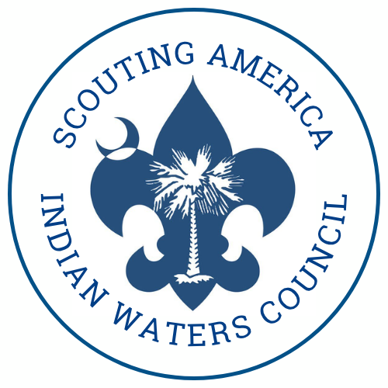

Recipient Name
Company Name
Company Address
Dear [Reference’s Name],
I am currently a Life Scout working toward the rank of Eagle Scout in Troop [Troop Number]. The Eagle Scout Rank is the highest in Scouting, and I have been working for many years to get to this point. As part of this process, I am required to request recommendations from individuals who know me and can speak to my character, leadership, and Scout Spirit.
The Indian Waters Council uses a secure online recommendation form instead of mailed or emailed letters. Please submit your confidential recommendation by using the link below:
Web Form Link: https://indianwaters.org/eagle-recommendation/
When completing the form, you will be asked to include:
- How long you have known me
- In what capacity you know me
- Your observations about my strengths, character, and leadership qualities
Important: Please make sure to enter Troop [Troop Number] in the form so your recommendation is correctly routed to the Eagle Board of Review.
Your recommendation is confidential and will be reviewed only by the Eagle Scout Board of Review. I will not see the content of your submission.
Thank you for supporting me in this important step of my Scouting journey!
Sincerely,
[Scout’s Full Name]
Troop [Troop Number]

